WiX: A Website Editor
- Sign up and choose a log-in name and password. I try to use my school password so I can remember it.
- Choose a template that you are interested in using.
- I searched for “education” templates and chose the one below. I can change the page background by clicking on the square in the menu on the left. I could have a colored background (replacing the white), a pattern or a video.
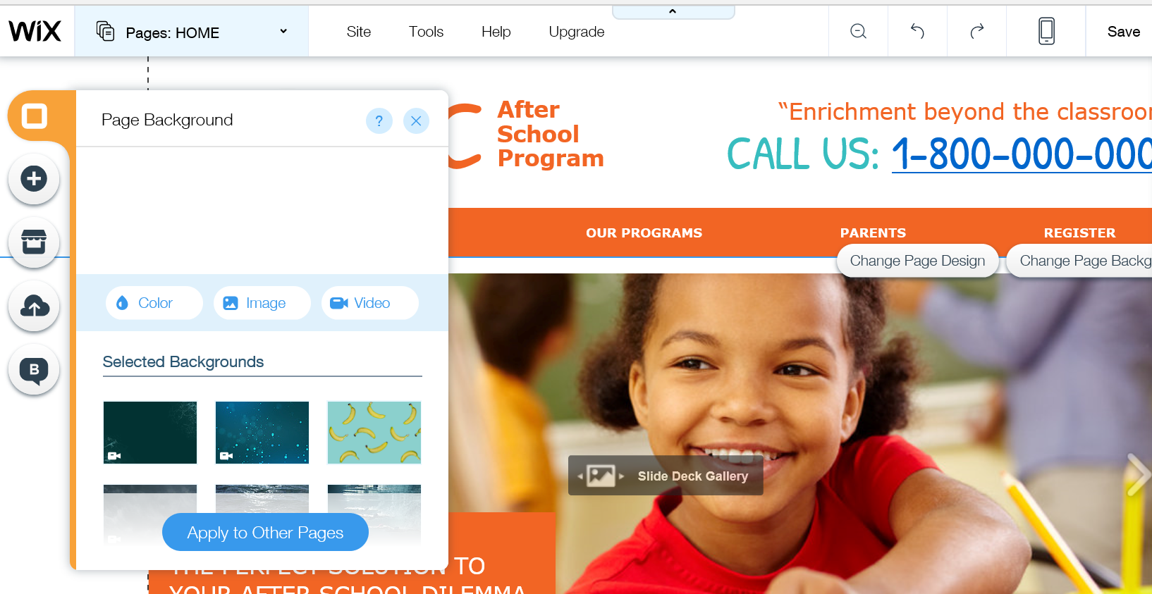

- Click the dialogue box or right click on any text or photo to change it. It is easy to upload your own photos. Just click “add images” and go find the pictures you want.
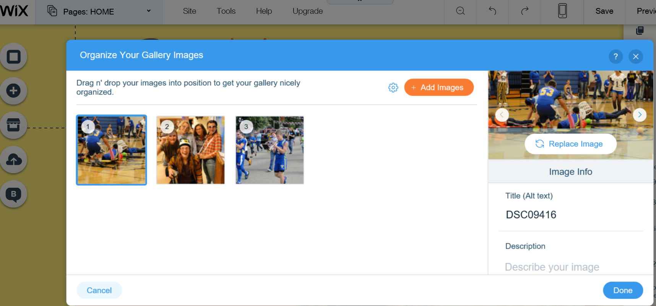

- If you click the “+” on the left-hand side, you can add any of the objects below.
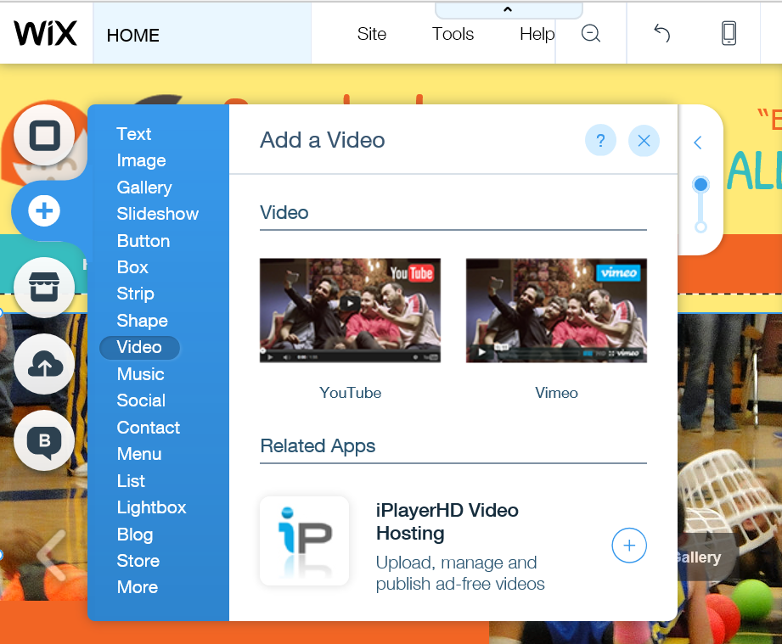

- Double click on the menu bar at the top to work on another page.

- Make sure you save using the free WiX domain.
- Link your WiX URL to your CMS for Schools home page.

